Leica Sp5 II Confocal User Guide

Turning on the Confocal System:

- Log in to the computer using your UMKC credentials.
- Turn on power switch one.
- Turn on power switch two
- Gently tilt the condenser arm of the microscope back.

Launching the Software

- Click on the LAS X icon.
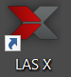
- A menu will appear.

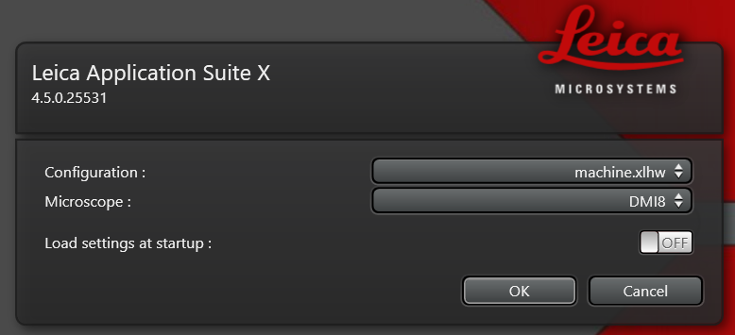

If the menu appears as above, no changes are necessary. If the configuration and microscope settings do not appear as above toggle the Configuration and Microscope setting to match that above. (Do NOT turn on the “Load settings at startup” switch.)
- Click “OK”

Initializing the stage:

- You should see the following window appear.

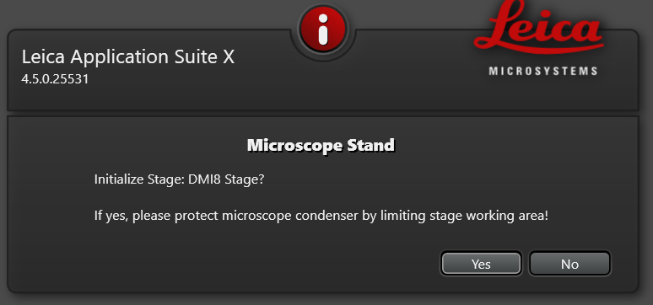

- If the condenser arm is tilted back then click "Yes".

- Initializing the stage is very important for time-lapse imaging, especially if you are using multiple stage positions. It is also important for tiling (montage) imaging.

Mounting your sample:

1. Samples must be mounted or cultured on a No 1.5 coverslip which are 0.17mm thick.
2. This is an inverted microscope so the coverslip should face the objective.
3. Carefully replace the condenser arm to the forward position.

Note:
If you need to use nail varnish or other sealants for your coverslip, MAKE SURE THAT THEY ARE COMPLETELY DRY before mounting them in the sample holder.

Most samples will use the universal sample holder.

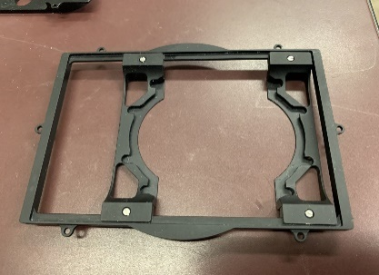
If you need a different sample holder or you need to use the climate controlled chamber and CO2 regulation, please ask for assistance.

BE VERY GENTLE WHENLOADING SAMPLE ONTO THE STAGE. DO NOT PRESS DOWN ON THE STAGE. THE STAGE POSITIONING COMPONENTS (GALVOS) CAN BE DAMAGED IF TOO MUCH WEIGHT IS PLACED ON THE SAMPLE HOLDER.

Finding your sample on the coverslip:

After initialing the stage, the front of the microscope should display the following window. Touch the color wheel and contrast button (Arrow) if this is not what is displayed.

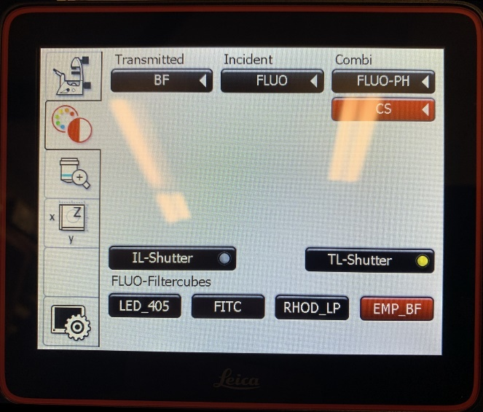

This window allows you to choose the contrast method for observing your sample through the eye pieces.

- To turn on transmitted light, press "BF" (Bright Field) and open the "TL-Shutter" (Transmitted Light). You should see a white light illuminating your sample.
- Use the X/Y/Z handset controller to position your sample over the objective, in your field of view.
- The focus knob on the side of the microscope turns clockwise to move the objective lens upwards toward the coverslip. Counter-clockwise moves the objective lens away from the coverslip.
- To use the fluorescent light to observe your sample choose the appropriate Fluorescence Filter cube and remember to open the IL-Shutter" (Illuminating Light) shutter.

Controls on the left side of the microscope allow you to:
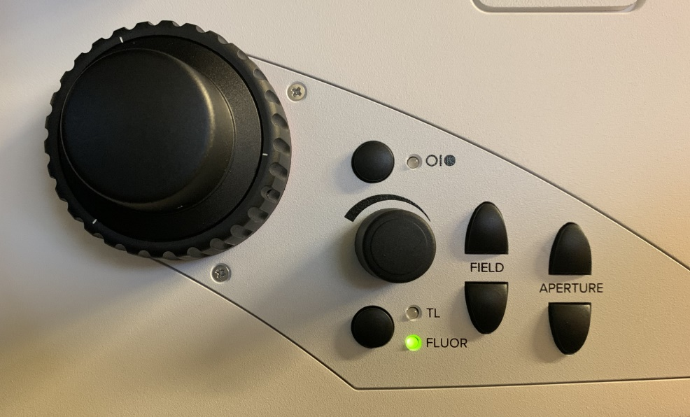
Focus Sample
Switch Between Transmitted and Fluorescent Light
Increase or Decrease Circle Size of Fluorescent Illumination
Adjust the Aperture for Transmitted or Fluorescent Light
Adjust Brightness of Light Source
Turn Light Source On and Off

Controls on the right side of the microscope allow you to:
Focus Sample
Set Focal point
Move Objective Away From Focal Point
Move Objective to Focal Point
Don’t Touch Me
Don’t Touch Me
Switch Between Fine and Coarse Focus Adjustment
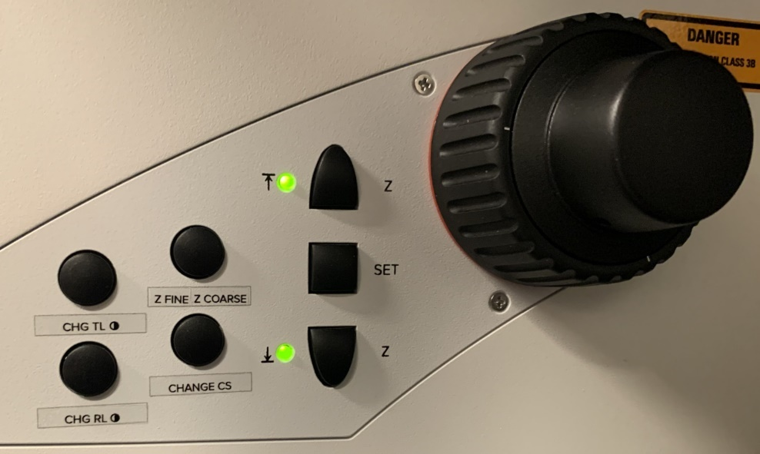

Once you have located your sample through the oculars and checked its fluorescence by eye, you are ready to move on to using the confocal microscope within the software.
Operating the confocal microscope system from within the software:
Working in the Configuration Tab:
- Turn on the 405nm laser and the White light laser by clicking on the configuration tab and then the "Laser Config" tab. Switch both lasers to the on position.
- The white light laser (WLL) should be set to 85% already.
- The 405nm laser diode has only one setting -on.
- Click the “Hardware” button.
- Check “Online Maximum Projection during Acquisition”.
- You may also set your bit depth in this window to 8, 12, or 16 bits per pixel.
- Return to the “Acquire” tab.

There are two main tabs that you will be working in, called “Open Projects” and “Acquisition”.

Working in the Open Projects Tab:

Loading a configuration from a previously saved image:

If you have a configuration template with your imaging settings, now would be a good time to load it. If you do not have a saved configuration template that you would like to use, you may also open up a previously saved image under the “Open projects" tab and apply the settings used to capture that image using the “Apply" Icon. All capture settings are saved with each image.

Working in the Acquisition Tab:

If you want further information about the objective lenses, in the Acquire tab you can find that under the “Objectives” drop down menu (e.g. this gives you information about their optical limits, etc) clicking once will display the objectives available. Selecting an objective changes the objective from that currently imaging to one selected. (A warning will come up if you are trying to switch from an air objective to an oil immersion objective, or vice versa.)
Our website also gives information about the objectives and we prefer that you get the information from there if possible.

If you are setting up a new acquisition without previous settings, proceed as follows:
- Search for or choose the first dye you wish to acquire from the dye library and drag it into the spectrum window. This will load a laser line and emission window appropriate for your dye.
- At this point, if you have forgotten to turn on your lasers the software will ask you to do this.
- You should see the excitation laser line and the emission spectrum of the dye displayed in the spectrum window. You can display the excitation spectrum of the dye by clicking on the left side of the spectrum button.
- Add additional dye channels by clicking the plus symbol and drag and drop another dye into the new spectrum window. Repeat for as many dyes as you have in your sample.
- Pseudo-colors are automatically designated.

*Note: For non-sequential image captures just drag and drop more than one dye into the same spectral window. The software will initially set optimized laser wavelengths and detection windows that can be customized later.

- The dye database is set up such that the excitation laser and detector windows are optimized for each combination of dyes.
- You may change the laser intensity by selecting the laser line in the spectrum window. A box will appear below the spectrum window which allows adjustment of the laser intensity hitting the sample. The laser intensity defaults to 2% of its maximum power.
- Click on the detector button to set the detector gain. Detector gains default to 2.5 on a scale that goes up to 500. A box will appear below the dye spectrum which allows the adjustment of the detector gains.

Manually setting your laser wavelength:

  - The laser you want must always be a wavelength that is to the left of the emission maximum of your dye.
  - Click on “Add Laser” and drag and drop the laser into the spectrum window at the desired wavelength.
  - The laser line will then be illustrated in the spectrum window.

Manually setting you detector range:
- The detector range must always be to the right of the laser line.
- Click to select a detector (HyDS1, HyDS2, HyDS3, HyDX4, or HyDS5)
- The detector range may be adjusted by grabbing the left hand side of the detector range or the right hand side of the detector range and adjusting the range limits.
- DO NOT overlap the collection window for any dye with any of the excitation laser lines, otherwise you will collect a lot of the excitation light rather than the light emitted by the dye.

Manually setting the pseudo-color:
- After manually setting your detector range, you may click on the lock symbol in the bottom left corner of a channel window to set a pseudo-color for that channel.
- Right Clicking the Spectrum window will allow you to reset the spectrum window and pseudo-color.

Setting a transmission channel:
- In order to enable a transmission image collection, you must first select the detector range for the channel with the laser wavelength you want to use.
- Below the detector range “Trans PMT – Off” will appear.
- Click on this. A small window below the spectrum window will appear where the transmission detector may be turned on, and the gain and offset of the signal adjusted.

Configuring your imaging format:
- This is done using the tabs in the acquisition menu (left side of screen)
- File format
  - Conventional Scanner–(default) settings: The default image dimensions are 512 x 512. The default scan speed is 400 Hz. The default scanner is the conventional scanner.
    - The maximum pixel dimension that can be captured by the conventional scanner is 8192 x 8192. The conventional scanner’s maximum speed depends on the pixel format chosen but peaks at 2600Hz. There is a button to the left of the file format that can be selected to optimize the XY format for the best resolution of the objective currently in use.
  - Resonant Scanner The maximum pixel array for the for the resonant scanner is 2048 x 2048. Its maximum scan rate is 8000hz. (It only scans at one speed.) The resonant scanner is most often used with live cell samples to minimize the pixel dwell time of the laser and reduce photo-beaching of dyes or phototoxicity.
    - Line averaging – As faster scan rates tend to produce noisier images, line averaging or frame averaging is available to average signal values at each pixel.
    - Line Accumulation – When using bit depths of 12 or 16, signals may be accumulated at each pixel. This is commonly used for images where the dynamic range of the signals measured include both extremely bright signal and extremely dim samples. This may be done by line or by frame.
- Zoom Factor– The zoom will default to 1.0 when using the conventional scanner. The zoom will default to 1.25 when using the resonant scanner. A good rule of thumb is to use 1.0x for the 100x oil objective and 3-3.5 for the 20 and 40x objectives. Otherwise, refer to the section on pixel size and resolution for guidance so that you don’t set the zoom beyond the pixel resolution of the objective.
- Pinhole – no need to adjust for most applications. The pinhole always defaults to 1 Airy unit (which is optimized for each objective). If you do need to alter the pinhole size for your application it is recommended not to go above 2 airy units.

“Fast Live” – in the bottom left of the screen there is a button labeled “Fast Live”. This is a preset combination of pixel dimensions and scan speed that is designed to let you preview your image while minimizing photobleaching and phototoxicity. It will let you preview one selected channel at a time. It is useful for quickly setting your focal plane and centering any features of interest in the image.
- When you have configured the HyD detectors and acquisition parameters, it is now time to get a live image to see what it looks like.
- Click the “Fast LIVE” button.

Optimizing the Image:

A lot of the optimizing is done using the dial controls on the control panel that is located behind the computer keyboard
- You may adjust the focus using the Z-focus dial (Clockwise = to go from the coverslip into the sample, counter clockwise = to go towards the coverslip).
- You can move around to center the feature of interest using the x,y,z stage controller (you can press “ctrl T” to display a crosshair that you can use to find the center of the image).
- Gain Adjustment - To increase the signal intensity, you should adjust the gain settings (dial on control panel) before resorting to increasing the laser power. To do this, click the mouse on the image (dye) that you want to adjust and then increase gain using the smart gain control dial.
- Use the “glow over/under” display setting when adjusting gain (QUICK LUT icon at top left of image screen) which pseudocolors the image to show saturated pixels in blue and pixels with zero values in green. You should adjust the gain until you can just see a few saturated blue pixels (or none).
- Gain recommendations – try not to go much above 100-300 for HyD detectors [maximum is 500]. If you hear a beep it means the gain has hit is maximum and you need to dial back. For the HyD X detector. An audible alarm will occur when the detector is saturated. The alarm will go off when the laser intensity and gains no longer saturate the detector.
- Transmission imaging: While adjusting the gain and smart offset you can toggle between the “glow over/under” display or the monochrome or pseudocolored images to make sure that the images look good.

NOTE 1 – Remember that your “Fast Live” image will look pretty grainy and ugly. Low line averaging is used to avoid bleaching your sample and the screen refresh rate is sufficiently fast for you to make adjustments easily. When you have optimized the “Fast Live” image, you will likely change the line averaging to a higher value which will give a much higher quality image.

NOTE 2 – A cool feature of the Leica Sp8 II system is that you can set separate gain adjustments for all 5 detectors. Many conventional LSCM microscopes can only apply a single gain to all the detectors.

NOTE 3 - When you are optimizing the image look out for potential “bleed through” of your dyes into the other channels. For example, DAPI has a very wide emission spectrum and often bleeds through into the GFP or FITC channel and even into the TRITC channel. You should suspect bleedthrough if your images have features that look very similar (e.g. you can see “nuclei” in the GFP channel, but you know your GFP should only be in the cell membrane). If you think a dye is bleeding through into another channel, you can check by turning off its excitation laser. If the other image is not affected, then there is probably no bleedthrough, but if the other image changes this is probably indicating a bleedthrough problem. If this happens you may be able to stop it by reducing the laser power on the dye that is bleeding through. Otherwise, you can set up a sequential acquisition where you image one or more dyes separately from the others.

- When you have finished optimizing the image, you can change the line averaging to a larger number (e.g. 32, 64, 96) and then take a snapshot image by clicking on the “capture image” icon to see if you like the result. If not, you can do more optimizing. We suggest 96 line averaging when using the resonant scanner. Less averaging may be necessary using the conventional scanner.
- Use “Start” to collect your optimized images.

Pixel Size and Resolution (Nyquist Principle)

Each objective has a limit of resolution. It is recommended that when you are zooming in on your samples you do not set your pixel size lower than:

objective resolution
2.3

If you set it lower than this it will lead to over sampling and can cause artifact in the image. This is the Nyquist Principle.

If you don’t know the objective resolution, it can be calculated by:

Objective resolution = 0.61 x emission wavelength
NA of objective lens

Therefore an overall formula that you can use to calculate the smallest pixel size is:

Smallest pixel size for max. resolution = 0.61 x emission wavelength
NA of objective lens
________________________
2.3

- The resolution can be changed either by changing the pixel dimensions (e.g. 512 x 512 changed to 1024 x 1024) or by changing the zoom.
- Once you reach the maximum resolution, you can increase the line averaging to improve the image quality.
- Remember that you can use the XY Format Optimization button to help you optimize the best pixel format for the resolution of the objective that you are using.

NOTE – below is a table of recommended values for the smallest pixel size of our confocal’s objectives with some of the commonly used fluorochromes for your reference. If you have multiple fluorophores, you should use the values for the dye with the longest wavelength (i.e.nearer to the red end of the spectrum).

Recommended Pixel Sizes (nm) for Optimal Resolution
Fluorophore | Objective
 | 5x (DRY) |  | 10x (DRY) |  | 20x (DRY) |  | 40x (OIL) |  | 100x (OIL)
 | NA | 0.15 | NA | 0.4 | NA | 0.7 | NA | 1.25 | NA | 1.44
DAPI | 804.49 |  | 301.68 |  | 172.39 |  | 96.54 |  | 83.80
Emission 455
GFP | 896.43 |  | 336.16 |  | 192.09 |  | 107.57 |  | 93.38
Emission 507
FITC | 917.65 |  | 344.12 |  | 196.64 |  | 110.12 |  | 95.59
Emission 519
TRITC | 1011.36 |  | 379.26 |  | 216.72 |  | 121.36 |  | 105.35
Emission 572
Cy3 | 1007.83 |  | 377.93 |  | 215.96 |  | 120.94 |  | 104.98
Emission 570
Cy5 | 1184.64 |  | 444.24 |  | 253.85 |  | 142.16 |  | 123.40
Emission 670

Z-stack Imaging:
Use the Z-stack acquisition menu tab for setting this up.

- On this menu there is a “cube” that shows you what your imaging volume looks like.
- You can set the “begin” and “end” positions of a z-stack by focusing up or down through the sample and defining where you want the acquisition to start and end. (Clockwise = goes from the coverslip into the sample, counter clockwise = goes towards the coverslip. Also, the more negative the number, the closer it is to the objectives)
- It is also possible to focus an image and set the Z-size which will automatically calculate the top and bottom of the stack.

Note: - you do not have to set “top” and “Bottom” - the software can start at the bottom and work up if you want or it can start at the top and work down if you prefer.
-If you are imaging deep into the tissue, the signal may be feinter and in that case it may be better to set the start point in the deeper parts first and work down towards the coverslip so as to image the feinter areas before they get bleached by the laser exposure.

- Once you have set the top and bottom, you will be able to see what the total thickness is that you are imaging,
- The system will suggest a default optimum step size. You can override that and set your own desired step size if you want.
- The number of slices that will be needed for the z-stack should also be displayed.
- Click “Start” to collect your image stack.

Compensation:

This feature is used to compensate for reduced signal intensity as you go deeper into the sample
- Click on compensation at the bottom of the Z-stack panel.
- Select compensation type. On the SP8 Stellaris, only compensation using changes in the gain on the signal are available. On other systems (our old SP5), the AOTF was able to control laser intensity as well as gains.
- Add beginning and end positions.
- Go to beginning of stack or whatever position is closest to coverslip.
- Turn on live imaging.
- With the quickLUT view selected begin moving away from the coverslip up the z-stack until the intensity begins to visibly fall off. At this point adjust the gain to match the image at the beginning point.(might need to take a picture on your phone for this)
- Add the point with adjusted settings into the compensation menu.
- Repeat until you have reached the top of a stack, then close out the compensation menu.
  - Note: the more points you select the more uniform the intensity of the stack will be.

Spectral Imaging

Spectral imaging can be set up by clicking on the drop-down menu at the top of the acquisition tab, under acquisition mode.
- Choices including “λ” in the option permit spectral scanning of the emission spectrum for a given laser excitation range.
- Choices including “Λ” in the option permit spectral scanning of the excitation range for a given sample emission range.
- Choices including “λ” and “Λ” in the option permits spectral scanning of the emission wavelength while also scanning the excitation wavelength.

Choosing a lambda scan option will open a submenu in the acquisition tab called “λΛ Excitation Emission Scan”. This menu permits setting the range of the excitation and emission bandwidths.
- In the “λΛ Excitation Emission Scan” panel use the Excitation Control and Emission Control submenus to set the range and step size of the excitation scan and emission scan respectively.
- Set the spectral range for emission and excitation and the step size of each for the spectral scans.
- Click “Start to capture the spectral scans.

Analysis of the λΛ data:
- Go to the tabs at the top of the image acquisition tab and choose “Process”.
- On the left side of the window a list of processing options will be shown.
- For analyzing λΛ scans select “Excitation/Emission Contour plot.
- Click “Preview” in the middle of the process window.
- Click “Apply” at the bottom of the window.
- You will be presented with a a 2-D histogram plotting brightnes at each excitation wavelength and emission wavelength.
- Selecting an xy coordinate within this contour plot will yield an image for each captured combination of excitation and emission selected.

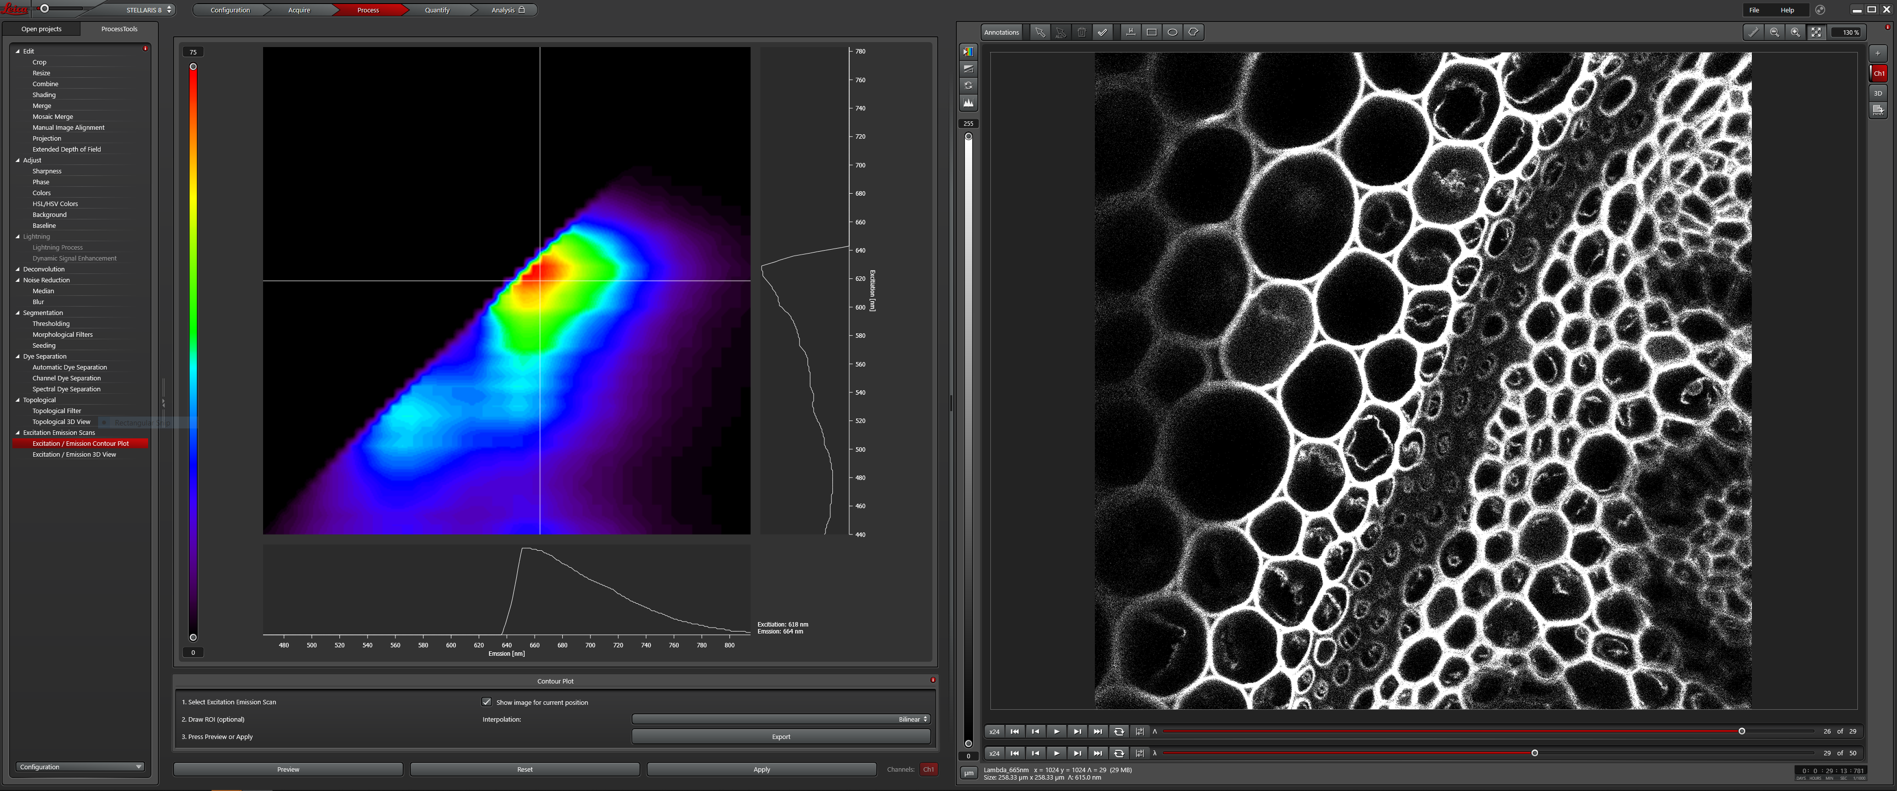
Time-Lapse Imaging:

Time lapse imaging can be set up by clicking on the drop-down menu at the top of the acquisition tab.
The default value for this drop-down menu is “XYZ”.
- Choosing an option that ends with “T” will open the timelapse tab within the Acquisition tab. There are many options.
- For instance, XYT permits two dimensional time-lapse captures.
- Choosing XYZT permits time-lapse captures of z-stacks.
- Choosing XYλT permits time-lapse captures of Lambda wavelengths scans.
- The Time-Lapse menu permits you to set the time interval between captures, the duration of the capture and/or the number of stacks in an XYZT collection.

*For chronic time-lapse experiments you will want to turn on “Autosave” in order to prevent data loss. Autosave saves data as you collect during a long time-lapse experiment.
- To turn on Auto-Save, go to the project settings drop-down menu at the bottom of the Open Projects Tab.
- Click on the plus symbol next to “Default settings for new projects”.
- A dialog box will open. Toggle the Auto-Save button to “ON”.

LAS-X Navigator:

LAS-X Navigator is a tool that facilitates setting up the collection of tiled images and multiple mark and find locations. LASX navigator permits you to use all the features above either in image tiling mode, or for multiple mark and find locations.
- To use, click on the grided box underneath “acquisition mode” in the acquisition tab.
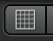
- A new interface will open with your image centered.
- Click on “Fast Live” in the lower left corner. Use this to focus your image.
- Click on “Spiral” in the lower left corner.
- The Image Navigator will start to collect images in a spiral sequence around your original image.
- Use the mouse wheel to zoom in or zoom out in the spiral image.
- The image may be dragged with the mouse to re-center the spiral image features.
- Stop the spiral when the area you wish to image has been collected.

Tiling:
- Choose one of the shape tools below the spiral image.
- Draw a region of interest around the area from which you wish to create a tiled image.
- Drawing a region of interest will construct a grid across your spiral image. The grid represents each of the images that will be collected in the tiled image.
- The size and number of squares in the grid can be changed using the zoom factor slider in the Scanmode dialog. You can Spiral at low zoom with fewer pixels to collect a quick overall image for navigation and collect at a high zoom with more pixels for better resolution captures.
- If you wish, you may preview the tiled image before your final capture using the preview button.
- Collect the final tiled image using the “Start” button.

Mark and Find:

For your experiment, you may not wish to capture an entire tiled image field. It may be more efficient to collect single images at multiple distinct locations. This is useful when you do not need a timelapse collection over an entire tiled area, or when you wish to capture z-stacks only at a subset of locations.
- Click on an area in the spiral image that you would like to capture.
- The image will update in the area that you clicked.
- Click the “Mark” button in the lower center.
- Mark the multiple regions of interest that you want to collect.
- These images will show up in the “Task List” in the bottom right.
- You may return to each marked position to fine tune your image, Z-stack, and/or time-lapse settings by selecting a marked image within the task list.
- You may also refine your image by resetting your focus using the “Redefine Z” but below the task list.
- Click Start to begin collecting your marked locations. Individual locations will be scanned in order from top to bottom, left to right.

Adaptive Focus for Live Imaging Applications:
For capturing an XYZT experiment, do the following:
- Turn on the adaptive focus by clicking on the adaptive focus icon at the top right of the acquisition panel.
- Select the “Adaptive Focus Control” for your focus system.
- The button with the arrows circling the T is used to designate the time points for which you wish the adaptive focus to be used (normally we select “every cycle”)
- The button with the arrows circling the tiling symbol is used to designate which positions you wish the adaptive focus to be used on (normally we select “every position”).
- Select AFC (the wrench)
- Turn AFC on, if it is not already on.
- Select “On demand mode”.
- Select “Hold plane in Z-stacks”. You may need to click this twice (Software bug).
- Turn on the fast scan and focus an image.
- Click “Store position”.
- At this point you may choose multiple mark and find positions using LASX Navigator.
- Select Start to capture.

Using HyD Detectors in Different Modes

- The HyDS detectors default to “Analog” operating mode but have several operating modes including “fast mode”, “counting”, “digital”, “analog” and “reflection”.
- The HyDX detector has only “Digital” and “Counting” modes. HyDX detectors see further into the red part of the spectrum.
  - Fast Mode – This operating mode is used when capturing images using the resonant scanner. TauSense is not possible in Fast Mode.
  - Counting – This operating mode makes it possible to perform quantitative image acquisition by displaying images based on the number of photons detected per pixel.
  - Digital – In this operating mode, light emitted by the specimen is displayed exactly as it is detected by the detector. You can control the gain on the signals in this mode.
  - Analog – This operating mode offers maximum sensitivity at low laser power. It is appropriate for live cell imaging where quantitative data is not needed.
- If you have samples that have a large dynamic range (e.g. very bright and very faint information on the same image) the HyD detectors can be used in Counting mode. This works best with high bit depth images. 8-bit images can count up to 256 photons per pixel. 12-bit images can count up to 4096 photons per pixel. 16- bit images can count up to 65,536 photon per pixel. (This is GREAT for generating beautiful images while simultaneously generating quantitative data.)
- When using the HyDS detectors or HyDX detectors in photon counting mode you do not want to have any line averaging, so this should be changed to zero.

Setting Up the Gas Regulator for Live Imaging

- Check the gas humidifier column to make sure it has sufficient clean water in it (level should be about 1cm below the max level)
- To avoid spillage of water into the microscope system in case there is a rapid initial surge of air bubbles, make sure that the opening of the green tubing is placed outside of the microscope chamber before you turn on the gas.
- Make sure the grey plug on the humidifier column is firmly placed (if not it may pop off when the gas is started or during your experiment).
- Turn on the gas at the tank.
- Pressure out of the tank regulator should be between 43 psi (minimum) to 140 psi (maximum). We normally set at 80psi.
- Pressure on the dial of the regulator control unit should read 0.166 (this equates to about 10L/h)
- Cover any holes in the stage adapter with tape to make sure that gas doesn’t escape during imaging.
- Place the CO2 hood over the sample making sure to use the glass panel and not the plastic one if using DIC.
- Connect the tubing from the CO2 hood to the green outlet tubing from the humidifier column and make sure that gas is flowing into the cover.

Tips for Live Imaging (Will need revision as more experiments are performed.

- When using the resonant scanner, use line averaging of 8-16 (32 is okay if necessary). Using the resonant scanner will minimize pixel dwell time for the laser and minimize photobleaching and phototoxicity.
- Lower the laser intensities as much as possible while still acquiring adequate detail. Keep laser powers at 2 or below for the stronger laser lines if at all possible. Preferable 7-8%.
- Limit the number of planes in z-stacks as much as possible.
- Open pinhole to 1.2-1.5 airy units to increase brightness at lower laser powers.
- For DIC images which have to be acquired in a separate scan from fluorescence images use the 593 laser at low power.
- Select positions and focal planes as efficiently as possible, minimizing light exposure and using longer excitation wavelengths when possible.
- When setting up for timelapse imaging, do all of your mark and finds to set the positions and set their Z-stacks, etc. before setting the time intervals.
- In the xyzt tab if you click “minimize” it will show you the minimum time interval that would be needed to complete a single acquisition of all the positions you have set. To get an accurate number, you need to have the line averaging set at the value you will use for your timelapse acquisition.
- Remember to set the adaptive focus when you do timelapse imaging, as that will help correct for any focal drift of the specimen.

Tiling and Mark and Find when using the “Lightning” software module.

“Lightning” is a method of on-the-fly image deconvolution which can improve signal to noise ratios while imaging. Lightning is included as a software module on all SP8 Stellaris systems. This can yield improved image resolution at the limits of resolution into the low hundreds of nanometers. Currently, lightning is not supported un the LASX- Navigator application. However, tiled images and mark-and-find functionality is preserved from the SP5.

Tiling (When using “Lightning” Only)

- For tiling (montage imaging) click on the grid icon
- Find one corner or edge of your sample. (it is often easier to do this in the microscope eyepieces).
- *Click on the Mark Position Icon (X-Y axis with a little square)
- If doing a z-stack set beginning and end for this region of the sample.**
- Move to the opposite edge or corner of your sample and repeat from * to ** adjusting the z-stack only if part of the sample is not covered in next region.
- If all sample is covered you can begin a test stack. If not move to additional corners/edges until you think you have the whole sample in the imaging area indicated on the panel.
- To run a test stack, use a small number of steps (5 or 6) and a low line averaging (around 6). (usually the “autostitching” is selected but smoothing is off)
- When this stack is complete make sure that the desired area is completely captured or adjust as needed.

Mark and Find (When using “Lightning” Only)

- For Mark and Find select the Icon with the axis and multiple small squares
- Find your first desired imaging region
- If doing a z-stack determine if each will have a different stack definition (most common) or if you will use the same stack parameters for all positions and mark the “Same Stack for All” check box accordingly.
- *Click on the Mark Position Icon (X-Y axis with a little square)
- If doing a z-stack set beginning and end for this region of the sample
- Go back to the Mark and Find tab
- Click on “redefine stack” **
- Then select your next Mark and Find and repeat from * to **

Turning off the Confocal System (instructions are posted in the room)

- Turn off the 405nm Diode Laser within the LAS-X software.
- Turn off the white light laser(WLL) within the LAS-X software.
- Exit the LAS-AF software
- Turn off power switches 2.
- Turn off power switch 1.
- The cooling system may continue to run after the power is turned off. The cooling system will turn itself off automatically.

